**Inputs:**

For the game to be played, it must be run using racket. Ideally by letting identify the language itself.

The game will prompt for 2 difficulty options, choose any.

The pieces can be moved using:

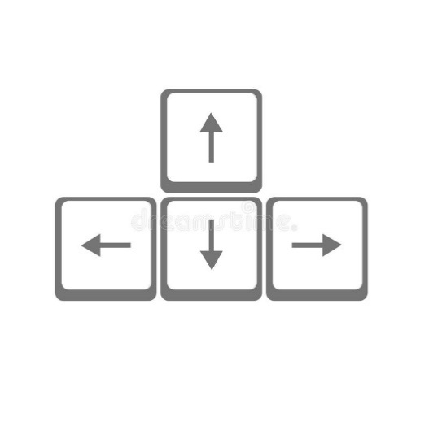

Rotated using space:



**Outputs:**

The game outputs the image displayed at the screen, including:

* Piece
* Board
* Background
* Scores
* Level

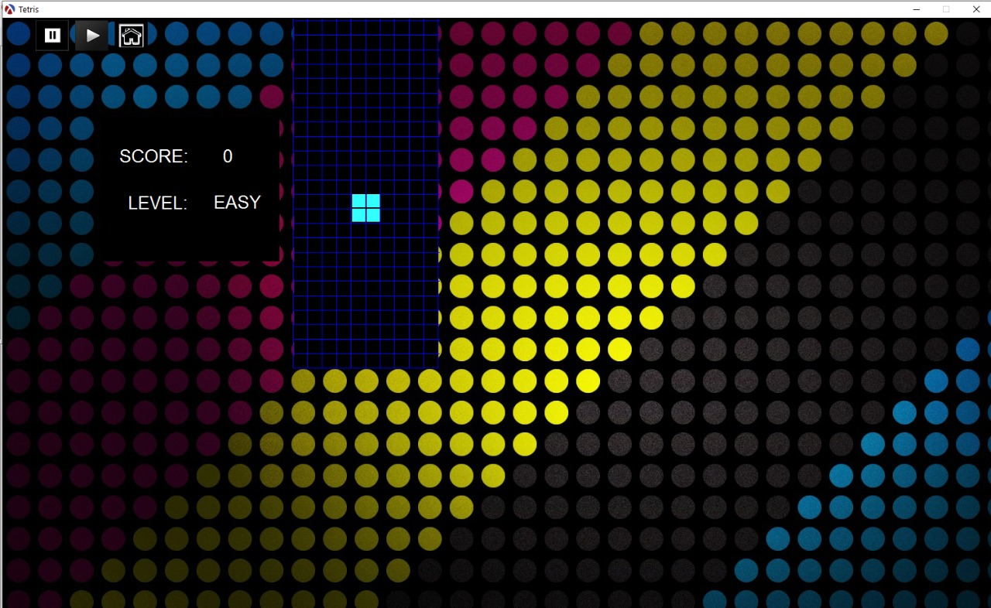

**Intent:**

Intended to be presented as the final project for the course of functional programming, the game was to be developed using racket, no other restrictions apply

**Scope:**

Consists of the classic tetris recreated using Racket. The game contains 2 levels, and aims to represent the most basic functions of tetris, as I did not comprehend programming thoroughly (this game was made when I was a freshman)

**Tetris**

1. **Title**: Tetris (Scheme)
   1. Designer and Programmer: Juan Pablo Ospina Bustamante
   2. Genre: Puzzle
   3. Platform: Personal Computer
2. **Gameplay and Content Synopsis**:

This is an implementation of the classic game tetris, the game mechanics are faithful to the original

1. **License:**

The game is based on Tetris; therefore, its concepts, rules and practices are public, but the game itself, assets and source code follow the MIT License.

1. **Mechanics:**

A static board is shown on screen and pieces are generated randomly from a selection of 4 pieces. The pieces can be rotated, and they “fall” 1 block to the bottom of the board per second, the player can also choose to move the piece faster to the bottom.

As soon as a piece touches the board’s bottom or another piece, it stops, and another piece is generated.

1. **Technology:**

Racket or Scheme is the programming language used for this game

1. **Target Audience:**

Any audience can play the game.

1. **Game Mechanics:**
   1. **Camera**: A fixed 2D camera is used
   2. **Peripherals**:

Keyboard